Batch: C3 Roll No.: 16010123217

Experiment No. 08

Grade: AA / AB / BB / BC / CC / CD /DD

Signature of the Staff In-charge with date

TITLE: Design and Demonstrate database Connectivity between PHP & MYSQL

AIM: Design and Demonstrate database Connectivity between PHP & MYSQL

_____________________________________________________________________
Expected OUTCOME of Experiment:

CO:
_____________________________________________________________________
Books/ Journals/ Websites referred:

1. Head First HTML5 Programming published by Shroff/O'Reilly in 2011.

2. HTML, XHTML, and CSS Bible, 5th Edition By Steven Schafe.
3. https://developer.mozilla.org/en-US/docs/Web/Guide/HTML/HTML5
4. https://www.w3schools.com/php/php_mysql_connect.asp

Pre Lab/ Prior Concepts:

PHP
The PHP Hypertext Preprocessor (PHP) is a programming language that allows web developers to create dynamic content that interacts with databases. PHP is basically used for developing web based software applications. This tutorial helps you to build your base with PHP.
The different server side technologies should be considered in the design of web pages.
The technology used can be PHP, ASP, JSP, ASP.NET etc.

PHP started out as a small open source project that evolved as more and more people found out how useful it was. Rasmus Lerdorf unleashed the first version of PHP way back in 1994.
- PHP is a recursive acronym for "PHP: Hypertext Preprocessor".
- PHP is a server side scripting language that is embedded in HTML. It is used to manage dynamic content, databases, session tracking, even build entire e-commerce sites.
- It is integrated with a number of popular databases, including MySQL, PostgreSQL, Oracle, Sybase, Informix, and Microsoft SQL Server.
- PHP is pleasingly zippy in its execution, especially when compiled as an Apache module on the Unix side. The MySQL server, once started, executes even very complex queries with huge result sets in record-setting time.
- PHP supports a large number of major protocols such as POP3, IMAP, and LDAP. PHP4 added support for Java and distributed object architectures (COM and CORBA), making n-tier development a possibility for the first time.
- PHP is forgiving: PHP language tries to be as forgiving as possible.
- PHP Syntax is C-Like.

Common uses of PHP
- PHP performs system functions, i.e. from files on a system it can create, open, read, write, and close them.
- PHP can handle forms, i.e. gather data from files, save data to a file, through email you can send data, return data to the user.
- You add, delete, modify elements within your database through PHP.
- Access cookies variables and set cookies.
- Using PHP, you can restrict users to access some pages of your website.
- It can encrypt data.

Characteristics of PHP
Five important characteristics make PHP's practical nature possible −
- Simplicity
- Efficiency
- Security
- Flexibility
- Familiarity

"Hello World" Script in PHP
To get a feel for PHP, first start with simple PHP scripts. Since "Hello, World!" is an essential example, first we will create a friendly little "Hello, World!" script.
As mentioned earlier, PHP is embedded in HTML. That means that in amongst your normal HTML (or XHTML if you're cutting-edge) you'll have PHP statements like this −
<html>
<head>
<title>Hello World</title>
</head>
<body>
<?php echo "Hello, World!";?>
</body>
</html>
It will produce following result −
Hello, World!
If you examine the HTML output of the above example, you'll notice that the PHP code is not present in the file sent from the server to your Web browser. All of the PHP present in the Web page is processed and stripped from the page; the only thing returned to the client from the Web server is pure HTML output.
All PHP code must be included inside one of the three special markup tags ATE are recognised by the PHP Parser.
<?php PHP code goes here ?>
<? PHP code goes here ?>
<script language="php"> PHP code goes here </script>
A most common tag is the <?php...?> and we will also use the same tag in our tutorial.
From the next chapter we will start with PHP Environment Setup on your machine and then we will dig out almost all concepts related to PHP to make you comfortable with the PHP language.

Installation of Php:
In order to develop and run PHP Web pages three vital components need to be installed on your computer system.
- Web Server − PHP will work with virtually all Web Server software, including Microsoft's Internet Information Server (IIS) but then most often used is freely available Apache Server. Download Apache for free here − https://httpd.apache.org/download.cgi
- Database − PHP will work with virtually all database software, including Oracle and Sybase but most commonly used is freely available MySQL database. Download MySQL for free here − https://www.mysql.com/downloads/
- PHP Parser − In order to process PHP script instructions a parser must be installed to generate HTML output that can be sent to the Web Browser. This tutorial will guide you how to install PHP parser on your computer.
The INSERT INTO statement is used to insert new rows in a database table.
Syntax Insert Data Into MySQL
- The SQL query must be quoted in PHP
- String values inside the SQL query must be quoted
- Numeric values must not be quoted
- The word NULL must not be quoted
The INSERT INTO statement is used to add new records to a MySQL table:
INSERT INTO table_name (column1, column2, column3,...)
VALUES (value1, value2, value3,...)

Inserting Data into a MySQL Database Table

Now that you've understood how to create database and tables in MySQL. In this experiment you will learn how to execute SQL query to insert records into a table.
The INSERT INTO statement is used to insert new rows in a database table.
Let's make a SQL query using the INSERT INTO statement with appropriate values, after that we will execute this insert query through passing it to the PHP mysqli_query () function to insert data in table.

Implementation Details: Code

Config.php – to establish connection:

<?php
session_start();
$servername = "localhost";
$username = "root";
$password = "";
$dbname = "codekeep";

$conn = new mysqli($servername, $username, $password, $dbname);
if ($conn->connect_error) {
die("Connection failed: " . $conn->connect_error);
}
?>

Login – to insert data into table
<?php
require 'config.php';
if(isset($_POST['submit'])){
$name = $_POST['name'] ?? '';
$email = $_POST['email'] ?? '';
$password = $_POST['password'] ?? '';
$confirm_password = $_POST['confirm_password'] ?? '';

$inQuery = "INSERT INTO USERS(name, email, password) VALUES('$name','$email','$password')";
$result = mysqli_query($conn, $inQuery);
}
?>

<!DOCTYPE html>
<html lang="en">
<head>
<link rel="stylesheet" href="login.css">
<meta charset="UTF-8">
<meta name="viewport" content="width=device-width, initial-scale=1.0">
<title>Signup</title>
</head>
<body>
<div class="form-container">
<div style="display: flex; flex-direction: row-reverse; justify-content: space-between; align-items: center;">
<h1>&lt;Code<span style="color: #1a4eaf">Keep&gt;</span></h1>
<h1><span style="text-align: left;">Create an account</span></h1>
</div>
<form method="POST">
<h1>Create your account</h1>
<div class="form-row">
<div class="form-group">
<label for="name">Enter Name</label>
<input required type="text" id="name" placeholder="Name" name="name">
</div>
<div class="form-group">
<label for="email">Enter Email</label>
<input required type="email" id="email" placeholder="Email" name="email">
</div>
</div>
<div class="form-group">
<label for="password">Password</label>
<input required type="password" id="password" placeholder="Password" name="password">
</div>
<div class="form-group">
<label for="confirm_password">Confirm Password</label>
<input required type="password" id="confirm_password" placeholder="Re-enter Password" name="confirm_password">
</div>
<div class="checkbox-container">
<input required type="checkbox" id="terms">
<label for="terms" class="checkbox-label">I accept the <a href="#">Terms and Conditions</a></label>
</div>
<button type="submit" name="submit">Create an account</button>
<div style="display: flex; justify-content: center; margin-top: 10px; gap: 5px;">
Already have an account? <a href="./login.php">Login</a>
</div>
</form>
</div>
</body>
</html>

OUTPUT:
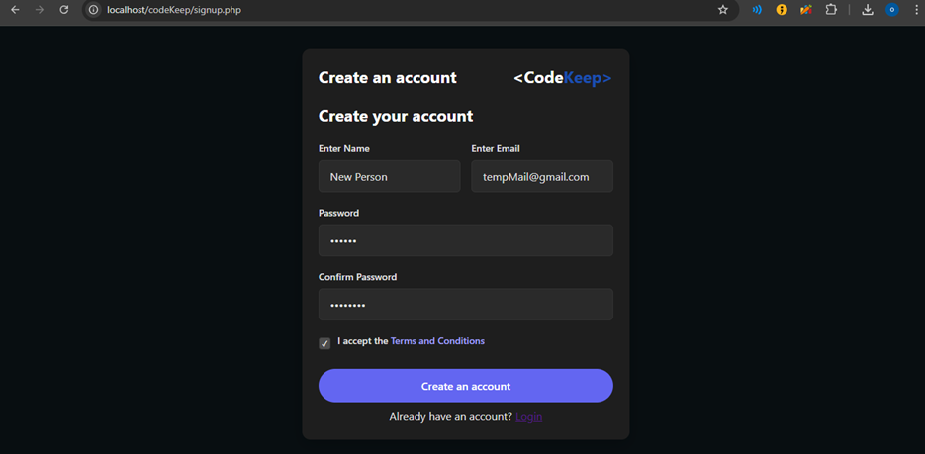
ALL USERS:
Using select command to get all users from the database and print their name and email and using for each loop to loop over the data.

<?php
require 'config.php';
$sql = "SELECT name, email FROM users";
$result = $conn->query($sql);
?>

<!DOCTYPE html>
<html lang="en">
<head>
<link rel="stylesheet" href="login.css">
<meta charset="UTF-8">
<meta name="viewport" content="width=device-width, initial-scale=1.0">
<title>All Users</title>
</head>
<body>
<div class="decorDarkBlue"></div>
<div class="decorLightBlue"></div>
<div class="container" style="display: flex; height: 100vh; justify-content: center; align-items: center;">
<div class="login">
<div class="box">
<h1>Code<span style="color: #1a4eaf">Keep</span></h1>
<h2>All Users</h2>
<table border="1">
<tr>
<th>Name</th>
<th>Email</th>
</tr>
<?php
foreach($result as $row){
echo "<tr><td>" . $row["name"]. "</td><td>" . $row["email"]. "</td></tr>";
}
?>
</table>
</div>
</div>
</div>
</body>
</html>
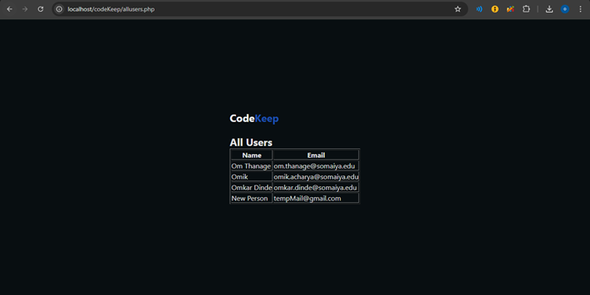

Steps for execution of the code
1- Create a database to store data into and fetch data from
2- Create a table using phpMyAdmin
3- Configure the database connection config.php
4- Create a query with data taken from form using POST method
5- Execute that query using mysqli_query
6- We retrieve data using the sql SELECT query and store the output in $result
7- We iterate over each result displaying them in the table
Conclusion:

This application runs on a standard LAMP-style setup, which traditionally includes Linux, Apache, MySQL, and PHP. In this context, PHP is used extensively to handle backend logic, manage sessions, and communicate with the MySQL database. The database is defined in config.php, where the application establishes a connection to store and retrieve data such as user credentials and profiles. Throughout the code, session_start() is invoked to enable PHP session handling, allowing user-specific data to persist between page navigations. Coupled with the use of cookies, this helps the application recognize returning visitors and handle authentication seamlessly.
HTML forms and basic validation are utilized for user inputs, like registration and login credentials. The application also employs the password_hash and password_verify functions in PHP to store and compare users’ passwords securely. Meanwhile, front-end elements rely on HTML, CSS, and JavaScript for layout, design, and interaction. CSS files, such as login.css and duels.css, set the visual style for various pages, defining layouts, color schemes, and component positioning. JavaScript (e.g., in index.js) adds interactivity—like rotating and translating card elements—to enhance user engagement.
The code demonstrates straightforward separation of concerns: the MySQL queries and session handling remain in PHP scripts, while CSS and JavaScript files manage user-facing presentation. Because of these familiar web technologies, the application is relatively easy to deploy and maintain, with the bulk of complexity handled by the PHP/MySQL integration and session-based authentication layer.

Post Lab Descriptive Questions (Add questions from examination point view)

1) What are the advantages of server side technologies that you used?
Answer:
- Enhanced security since data is stored on the server rather than the client's browser, protecting sensitive information from unauthorized access.
- Ability to store larger amounts of data compared to cookies, which have size limitations (typically 4KB).
- Better data integrity as server-side data cannot be tampered with by users, unlike cookies which can be modified client-side.
- Centralized data management that maintains state across multiple pages without exposing information to the client.
- Automatic garbage collection that cleans up expired session data, reducing storage overhead and improving performance.

2) Which function is used for database connectivity in PHP?
Answer:
$conn = new mysqli($servername, $username, $password, $dbname);

3) How would you redirect the page in PHP?
Answer:
header("Location: login.php");

Date: 18-03-25 Signature of faculty in-charge

